B.Tech. III Year I Semester

Course Code | Course Title | L | T | P | Credits
CS506PC | UI design- Flutter | 0 | 0 | 2 | 1

Course Description: This Course provides hands-on experience in creating visually appealing and responsive user interfaces using the Flutter framework. Participants learn to build cross-platform applications with a single codebase, utilizing Flutter & widget-based architecture to craft beautiful designs for both iOS and Android platforms. The lab emphasizes practical skills in UI development, enhancing proficiency in Flutter rich set of tools and components.
Course Outcomes: After completion of this course, the student will be able to
C506.1 Apply the basics of the Dart programming language, Flutter Widgets.
C506.2 Create responsive UI Widgets using navigator in Flutter Applications
C506.3 Implement a form with various input fields and animations, along with validation and error
handling.
C506.4 Demonstrate Flutter Application using REST API and Flutter debugging tools.
TASK1
- Install Flutter and Dart SDK.

Procedure

Step 1: Download Flutter SDK

Step 2: Extract Flutter SDK

Step 3: Verify Installation

Step 4: Install Dart SDK

1)sudo apt update
2)sudo apt install -y curl git unzip xz-utils zip libglu1-mesa
3)cd ~
curl -LO https://storage.googleapis.com/flutter_infra_release/releases/stable/linux/flutter_linux_3.19.0-stable.tar.xz
4)tar xf flutter_linux_*-stable.tar.xz
5)nano ~/.bashrc
6)paste this line----export PATH="$PATH:$HOME/flutter/bin"
7)source ~/.bashrc
8)flutter doctor
9)Open VS Code
Go to Extensions (Ctrl + Shift + X)
Install:
Flutter (by Dart Code)
Dart (auto-installed with Flutter)
Restart VS Code after install.
9)sudo snap install android-studio --classic
10) install chrome
wget https://dl.google.com/linux/direct/google-chrome-stable_current_amd64.deb
sudo dpkg -i google-chrome-stable_current_amd64.deb
google-chrome
11)sudo apt update
sudo apt install clang cmake ninja-build pkg-config libgtk-3-dev
12) flutter doctor --android-licenses
13) install flutter and dart plugins in android studio
set sdk path in android studio---home/flutter/bin/cache/dart-sdk
ASSIGNMENTS QUESTIONS
- What is the purpose of the flutter doctor command?
- How can you verify the installation of Dart SDK?
- What are the system requirements for installing Flutter and Dart SDK?
- Why is it important to add the flutter/bin directory to the system's PATH environment variable?
- Can you install Dart SDK separately from Flutter? Explain

What is Dart?
Dart is a programming language developed by Google. It is mainly used to develop Flutter mobile applications, web applications, and desktop applications.

Structure of a Simple Dart Program
void main() {
print("Hello World");
}

Explanation
Code | Meaning
void | The function does not return any value.
main() | Starting point of every Dart program.
{ } | Contains the program statements.
print() | Displays output on the screen.
; | Marks the end of a statement.

Output
Hello World

Example 1: Addition of Two Numbers
void main() {
int a = 10;
int b = 20;
int sum = a + b;
print("Sum = $sum");
}

Output
Sum = 30

Explanation
- int → Integer data type
- a = 10 → Stores 10 in variable a
- b = 20 → Stores 20 in variable b
- sum = a + b → Adds the two numbers
- print() → Displays the result

Example 2: Finding Even or Odd
void main() {
int num = 7;
if (num % 2 == 0) {
print("Even Number");
} else {
print("Odd Number");
}
}

Output
Odd Number

Explanation
- % gives the remainder.
- If remainder is 0 → Even
- Otherwise → Odd

Example 3: Using a Loop
void main() {
for (int i = 1; i <= 5; i++) {
print(i);
}
}

Output
1
2
3
4
5

Explanation
- for loop repeats statements.
- i++ increases the value by 1 each time.

Example 4: Function in Dart
void greet() {
print("Welcome to Flutter");
}
void main() {
greet();
}

Output
Welcome to Flutter

Explanation
- greet() is a user-defined function.
- main() calls the function.

Example 5: Taking User Input
import 'dart:io';
void main() {
print("Enter your name:");
String? name = stdin.readLineSync();
print("Hello $name");
}

Sample Output
Enter your name:
Sruthi
Hello Sruthi

Here is a basic dart program that covers some basic concepts like variables, functions, conditionals, loops, and classes:
TASK 1B
void main() {
// Variables
var name = 'Srinivas';
int age = 20;
double height = 5.9;
bool isAdult = age > 18 ? true : false;

// Print statements
print('Name: $name');
print('Age: $age');
print('Height: $height');

// Conditional statement
if (isAdult) {
print('$name is an adult.');
} else {
print('$name is not an adult.');
}

// Function call
greet(name);

// Loop
for (int i = 1; i <= 5; i++) {
print('Loop iteration $i');
if (i == 3) {
break;
}
}

// Friends array
List<String> friends = ['Bhanu', 'Amar', 'Amulya', 'Kiran', 'Sandeep'];

// Looping through the friends array
for (String friend in friends) {
print('Hello, $friend!');
}

// Creating an object of the Person class
Person person = Person(name, age, height);
person.introduce();

// Exception handling
try {
// Code that may throw an exception
int result = 10 ~/ 0; // Floor division by zero
print('Result: $result');
} catch (e) {
// Handling the exception
print('An error occurred: $e');
}
}

// Function definition
void greet(String name) {
print('Welcome to SDC, $name!');
}

// Class definition
class Person {
String name;
int age;
double height;
bool isAdult;

// Constructor
Person(this.name, this.age, this.height) : isAdult = age > 18;

// Method
void introduce() {
print(
'My name is $name, I am $age years old and my height is $height feet.');
}
}

/> dart run
Name: Srinivas
Age: 20
Height: 5.9
Srinivas is an adult.
Welcome to SDC, Srinivas!
Loop iteration 1
Loop iteration 2
Loop iteration 3
Hello, Bhanu!
Hello, Amar!
Hello, Amulya!
Hello, Kiran!
Hello, Sandeep!
My name is Srinivas, I am 20 years old and my height is 5.9 feet.
An error occurred: Unsupported operation: Infinity
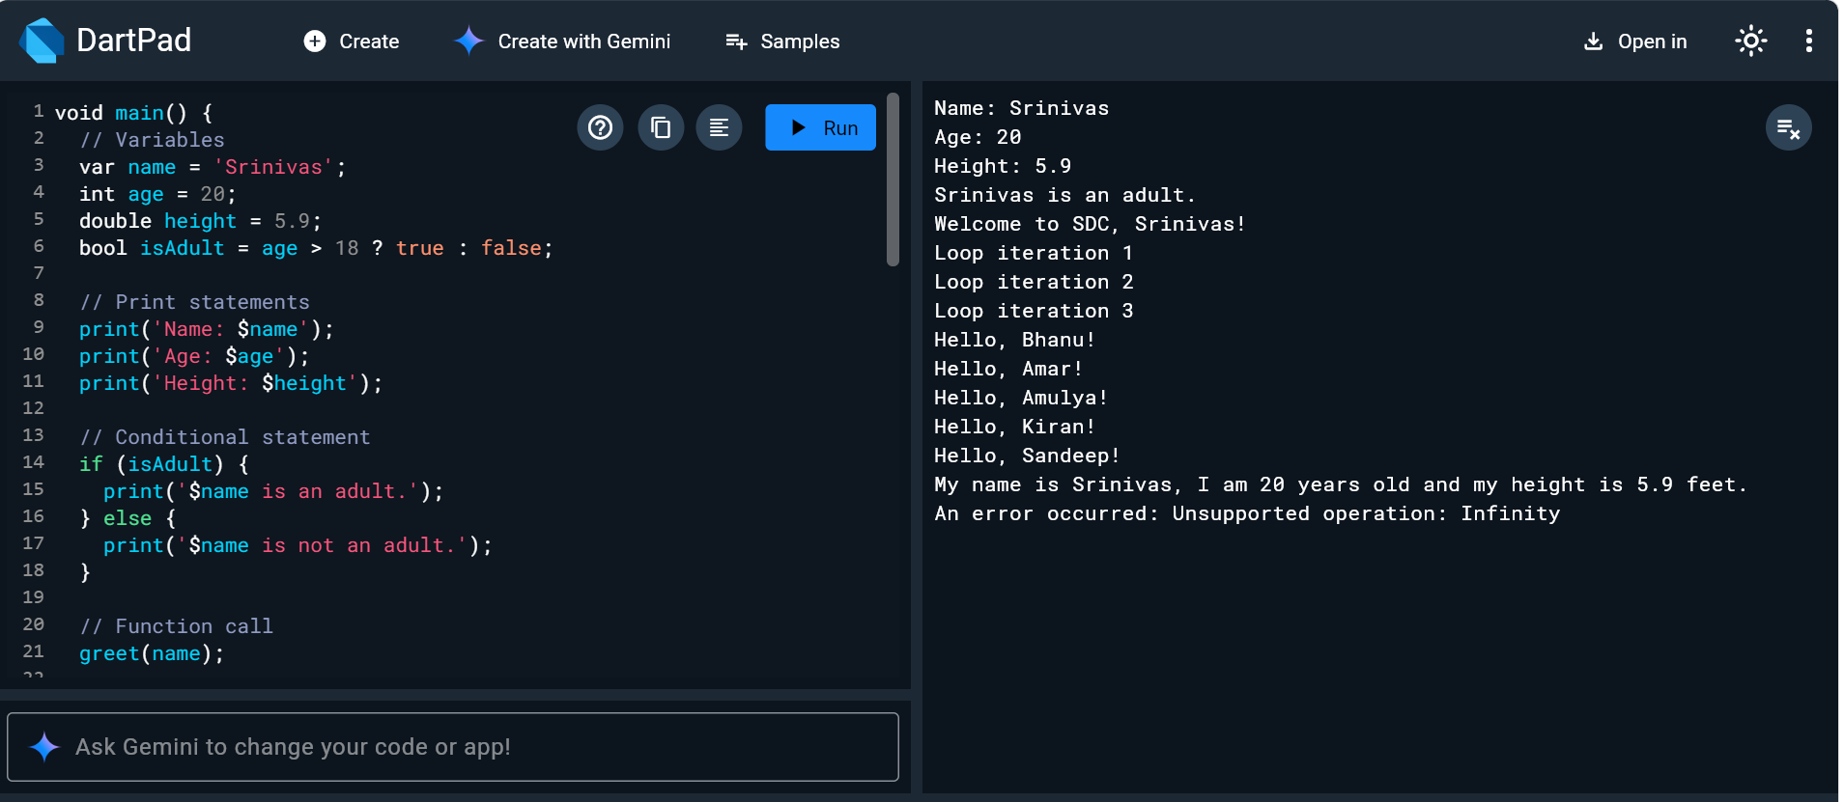
SAMPLE DART PROGRAMS
Example1:Calculator using Dart
import 'dart:io';
void main() {
print("===== Simple Calculator =====");
stdout.write("Enter first number: ");
double num1 = double.parse(stdin.readLineSync()!);
stdout.write("Enter second number: ");
double num2 = double.parse(stdin.readLineSync()!);
print("\nChoose an operation:");
print("1. Addition (+)");
print("2. Subtraction (-)");
print("3. Multiplication (*)");
print("4. Division (/)");
stdout.write("Enter your choice (1-4): ");
int choice = int.parse(stdin.readLineSync()!);
switch (choice) {
case 1:
print("Result = ${num1 + num2}");
break;
case 2:
print("Result = ${num1 - num2}");
break;
case 3:
print("Result = ${num1 * num2}");
break;
case 4:
if (num2 != 0) {
print("Result = ${num1 / num2}");
} else {
print("Error: Division by zero is not allowed.");
}
break;
default:
print("Invalid choice!");
}
}
